CS 255 System Design Document Template

This template lays out all the different sections that you need to complete for Project Two. Each section has guidance to prompt your thinking. You will need to continually reference the interview transcript as you work to make sure that you are addressing your client’s needs. There is no required length for the final document. Instead the goal is to complete each section based on what your client’s needs are. Remove this note when you are finished, and replace all bracketed text with the relevant information.

UML Diagrams

UML Use Case Diagram
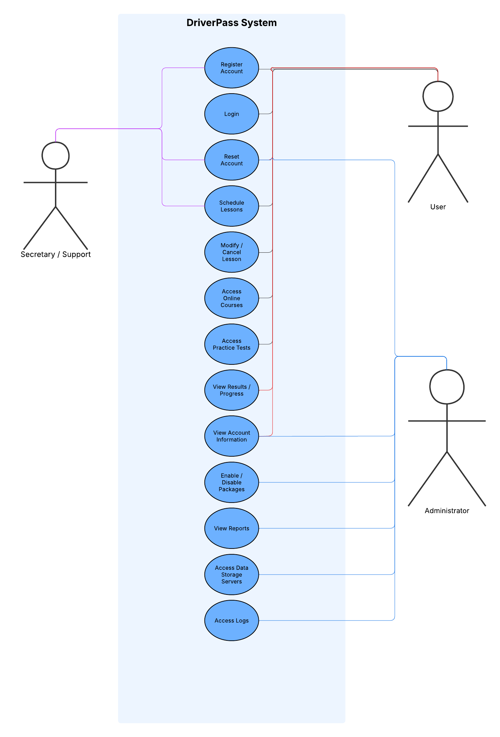

UML Activity Diagrams
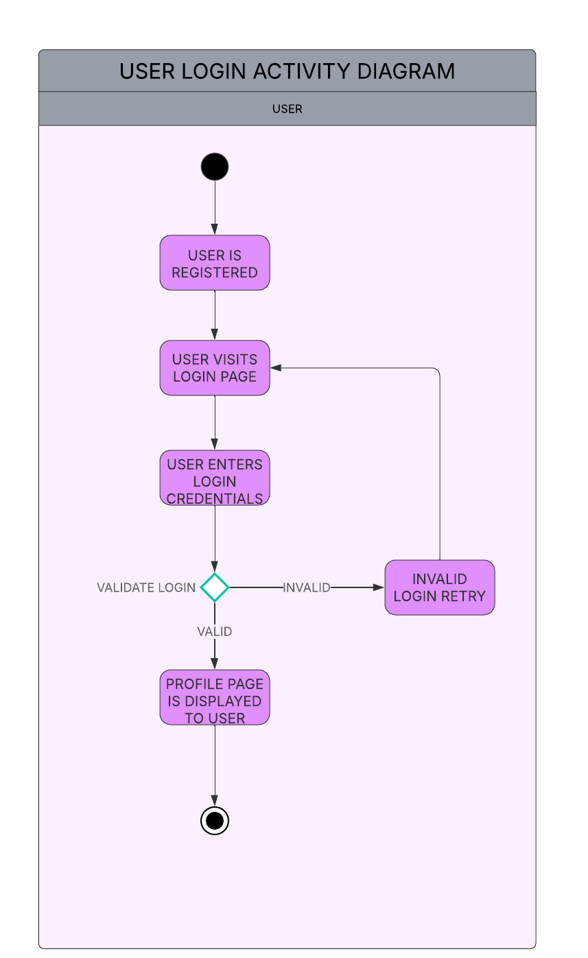
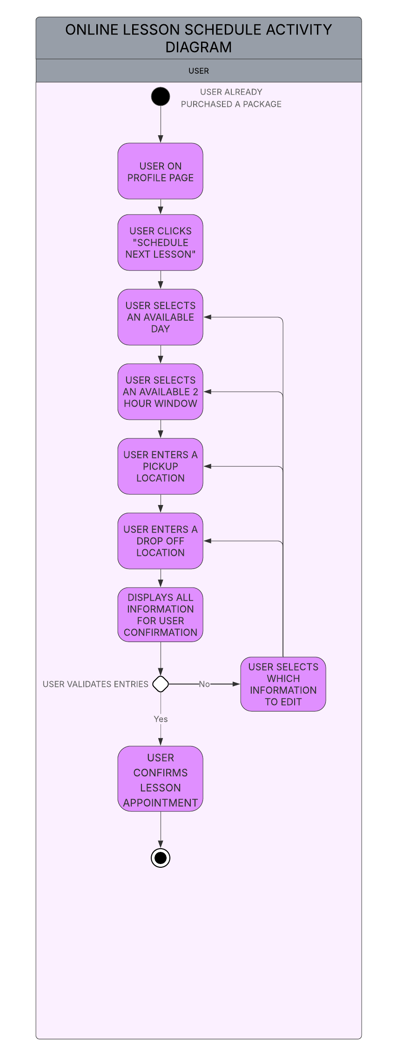

UML Sequence Diagram
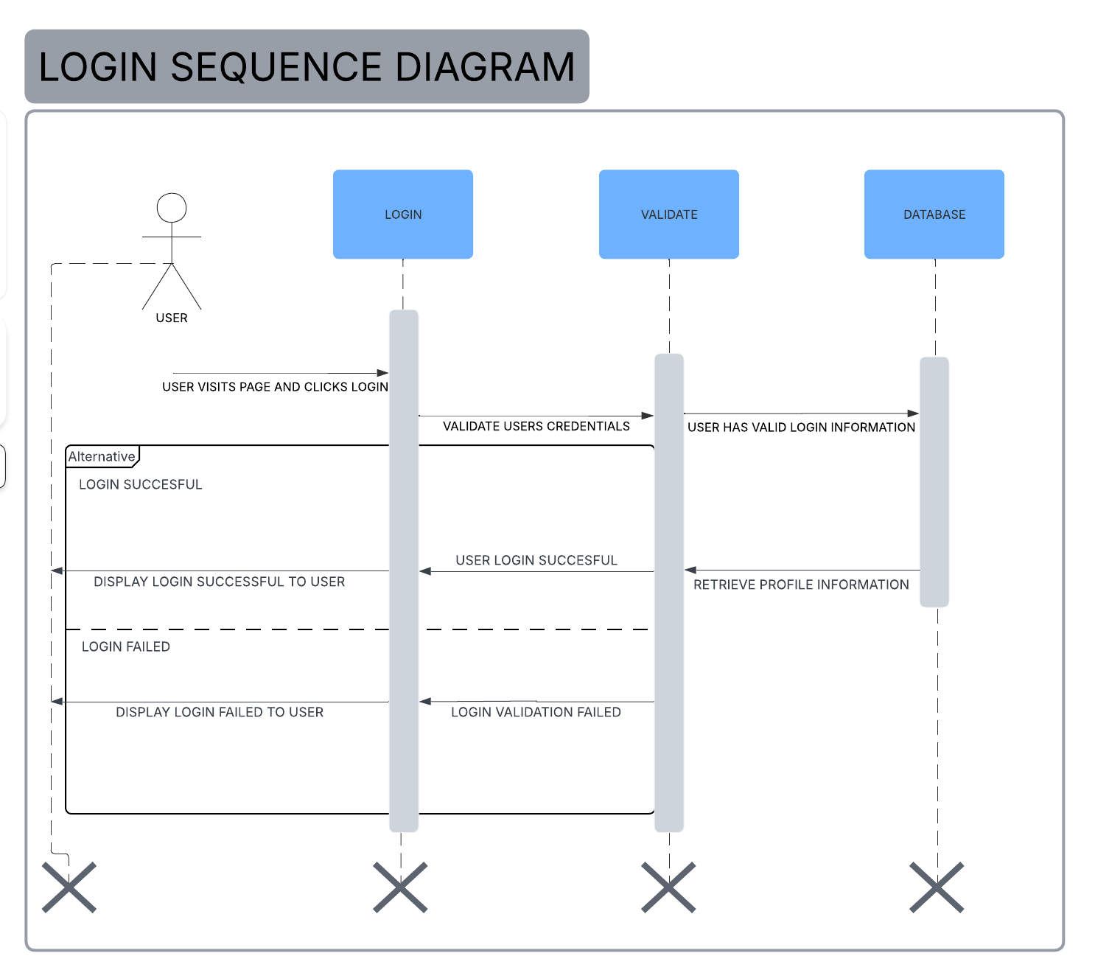

UML Class Diagram
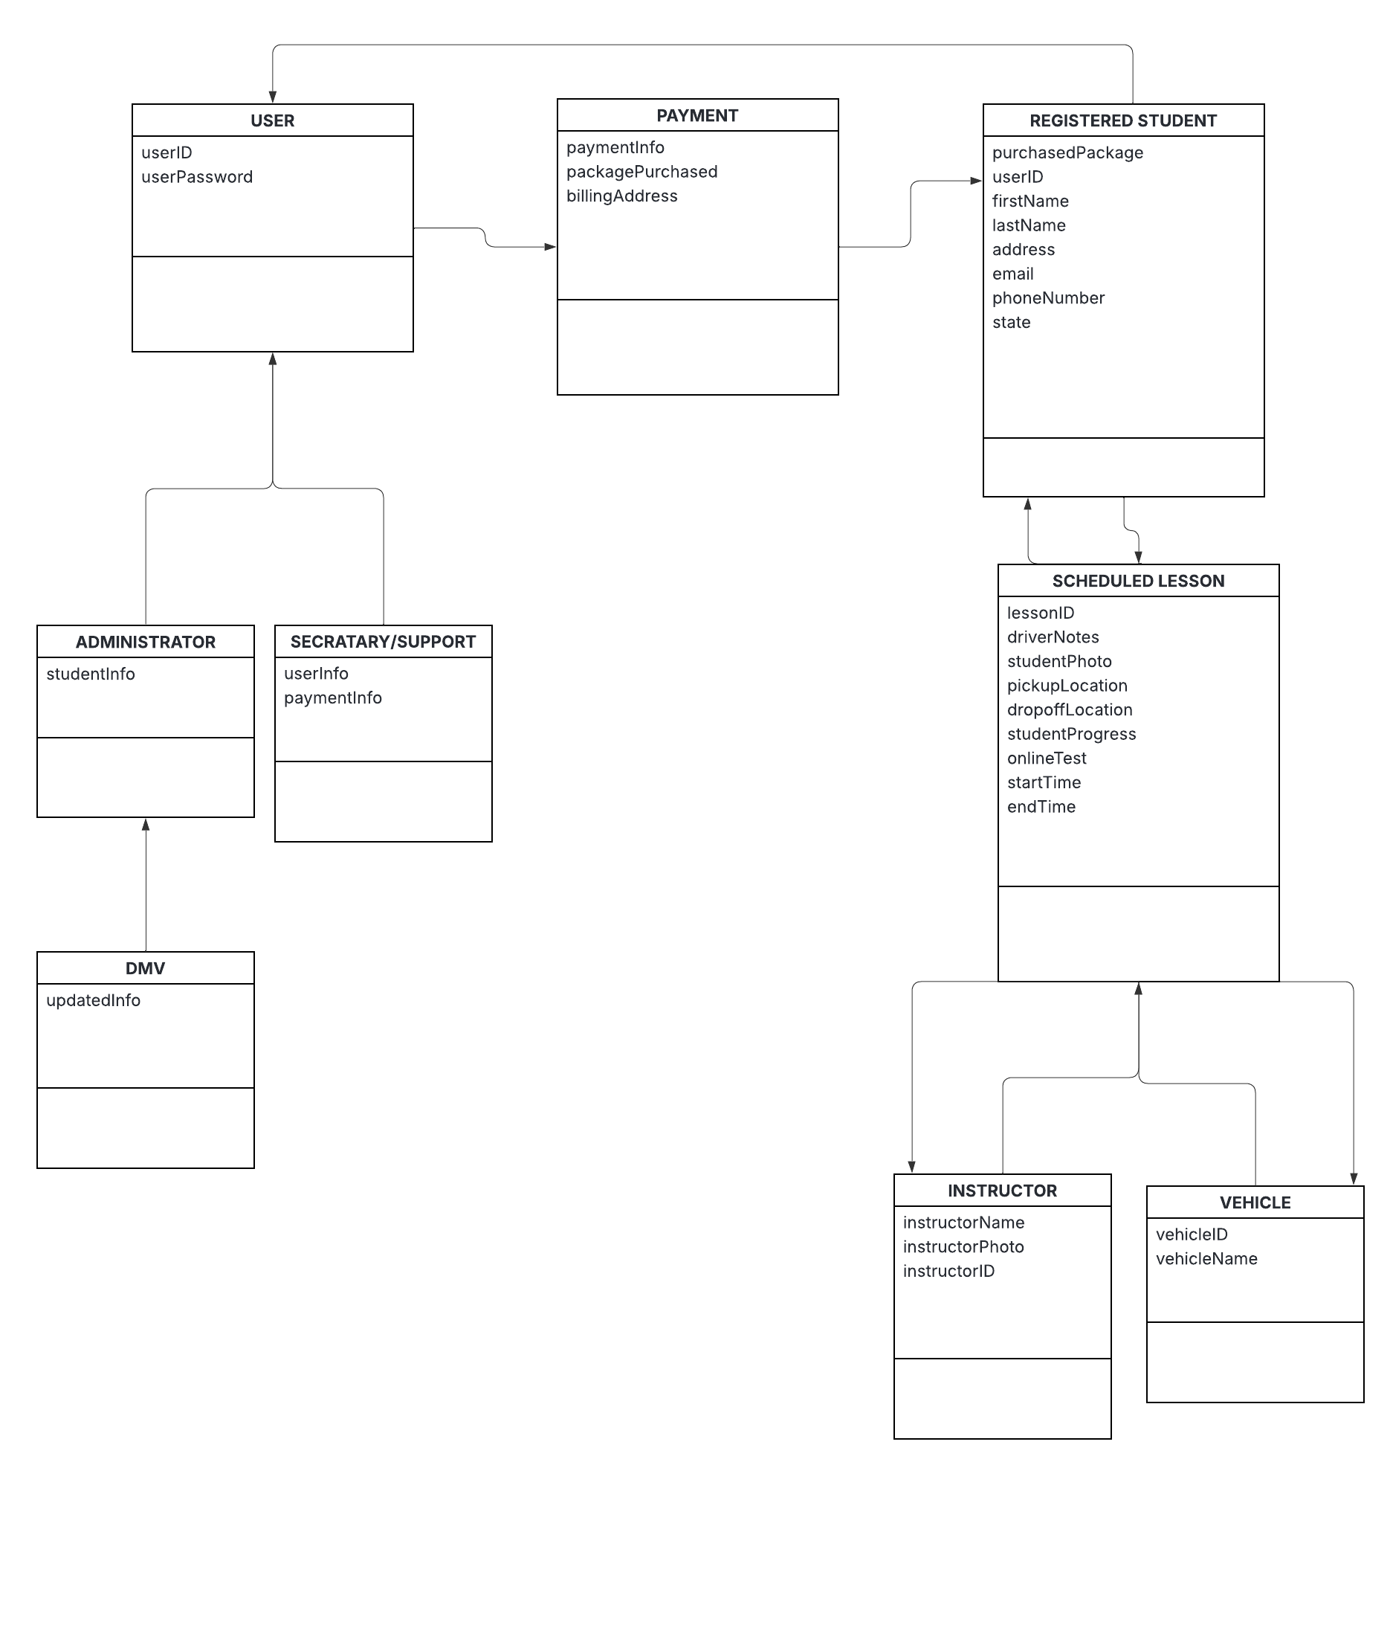

Technical Requirements
Based on this system design, this system will require server hardware or cloud access to ensure that the system always remains online and accessible. The server hardware will also help to support student authentication, scheduling, payment processing data, and user management by administrative users. The system will also require client hardware and network equipment or access to access the system. This system will also require database software and payment processing software to ensure a persistent and secure storage source for ensuring data integrity. This system will require strict security requirements to ensure the safety of underage data and the integrity of any stored information. Logging and monitoring tools are also necessary for administrative users to monitor and modify the system. This should also include role based restrictions to ensure all users have appropriate access.

